**Assignment 2.1 – Rock Paper Scissors Shoot!**

This assignment is about an event programming and JavaFX components.

You will develop the Rock Paper Scissors Shoot Game. There are two players: You(User) , and Computer. The program will randomly select the possible Rock, Paper and Scissors for the computer. While you(user) will select by click the Rock, Paper and Scissors buttons on the window.  The game should report the counting score for you and computer (Win =1, Loss = 0). The reset button used for resetting the score to 0s for you and computer. And the exit button used for exiting the program.

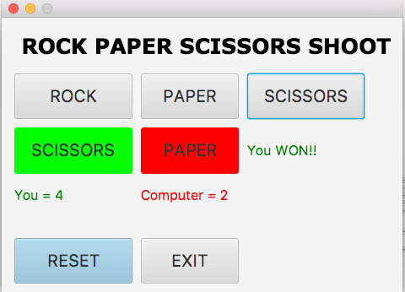

**Submission**

After completing this programming assignment, zip up all the classes and java file. The name of zip file MUST be COP3809_ASSIGNMENT21_SYY_XXXX.zip where YY is 01, 02 or 03 and XXXX is student id.

**Note: You can customize the Pane Layout, decorate the buttons with any images and feel free to prettify the user interface.**